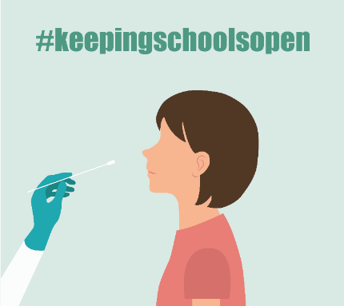
Kauj Ruam 1: Muab cov khoom li hauv qab no:
- Ob tug pas kuaj COVID-19 Antigen Rapid Tests (nrog cov lus qhia).
- Ib lub cuab yeej uas siv tau internet los xa koj cov kev kuaj tau (results) mus rau ntawm lub link muab los ntawm koj lub tsev kawm ntawv. (Yog hais tias koj tsis muaj ib lub cuab yeej lossis internet, hu rau Primary ntawm (650) 275-5419.

Kauj Ruam 2: Kuaj koj tus menyuam (los yog koj tus kheej yog tias koj yog ib tug neeg ua haujlwm)
SCAN tus QR code (saib hauv qab no) mus SAIB ib daim video tias yuav kuaj licas.

Kauj Ruam 3: Muab koj cov kev kuaj tau (results) los qhia rau Primary.Health. (TSIS TXHOB siv iHealth app.)
Yog tias tseem tsis tau cuv/sau npe, mus rau Primary Health ntawm https://my.primary.health/l/scusd-edu
Thov qhia cov kev kuaj tau (results) tias muaj mob, tsis muaj mob lossis tsis paub meej mus rau Primary Health.
YOG TIAS TSIS MUAJ INTERNET? Hu tuaj qhia txog koj cov kev kuaj tau (results) rau ntawm
Tus QR code rau kev cuv npe
(650) 275-5419

Kauj Ruam 4: Nkag siab txog koj cov kev kuaj tau (results)
YOG KUAJ TAU TIAS MUAB MOB (POSITIVE).
- Nyob twb ywm hauv tsev thiab tiv tauj koj tus kws kho mob, koj lub tsev kawm ntawv thiab email covidreport@scusd.edu tam sim ntawd rau kev taw qhia ntxiv.
YOG KUAJ TAU TIAS TSIS MUAJ MOB (NEGATIVE).
- Yog tias koj tus menyuam kawm ntawv nyob zoo thiab tsis muaj cov tsos mob ntawm tus kab mob COVID-19, ROV QAB TUAJ KAWM NTAWV!
- Yog tias koj tus menyuam muaj COV TSOS MOB lossis nyob ze nrog ib tug neeg muaj tus kab mob COVID-19, thov nyob twb ywm hauv tsev thiab HU RAU LUB TSEV KAWM NTAWV ua ntej lawv rov qab tuaj kawm ntawv – txawm tias qhov kev kuaj yog negative. Yuav tau ua kev kuaj ntxiv.
COV KEV KUAJ TAU (RESULT) QHIA TSIS MEEJ. Hu rau lub tsev kawm ntawv rau cov kauj ruam tom ntej, los nrhiav hnub yuav kuaj nyob hauv tsev kawm ntawv tom ntej, lossis nrhiav ib lub chaw muab kev kuaj nyob hauv zos kom rov kuaj dua. Nco ntsoov thaij ib daim duab ntawm koj qhov kev kuaj.
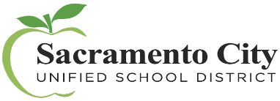
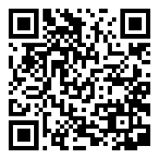
Puas muaj lus nug txog Primary.Health? Hu rau (650)-275-5419
SCAN tus QR code mus SAIB
ib daim video tias yuav kuaj licas.
Lub Ib Hlis Ntuj 2022

