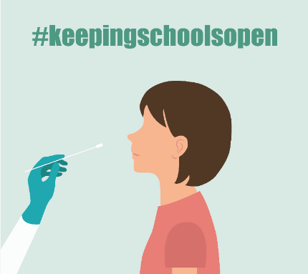
Step 1: Get the following materials:
- Two COVID-19 Antigen Rapid Tests (with instructions).
- A device with internet access for submitting your results at the link provided by your school. (If you do not have a device or internet, call Primary at (650) 275-5419.

Step 2: Test your student (or yourself if you are a staff member)
SCAN the QR code (see below) to WATCH a video on how to test.

Step 3: Share your test results on Primary.Health. (DO NOT use the iHealth app.)
If not already registered, go to Primary Health at https://my.primary.health/l/scusd-edu
Please report negative, positive or inconclusive results to Primary Health.
QR code to register:
NO INTERNET? Call your results in at (650) 275-5419

Step 4: Understand your test results
POSITIVE TEST?
- Stay home and contact your doctor, your school and email covidreport@scusd.edu right away for further guidance.
NEGATIVE TEST?
- If your student feels well and has no COVID-19 symptoms, RETURN TO SCHOOL!
- If your student has SYMPTOMS or has been in contact with someone with COVID-19, please stay home and CALL THE SCHOOL before they return – even if the test is negative. More testing may be needed.
UNCLEAR TEST RESULTS? Contact the school for next steps, to find the next in-school testing date, or find a local testing site to retest. Make sure you have a photo of your test.
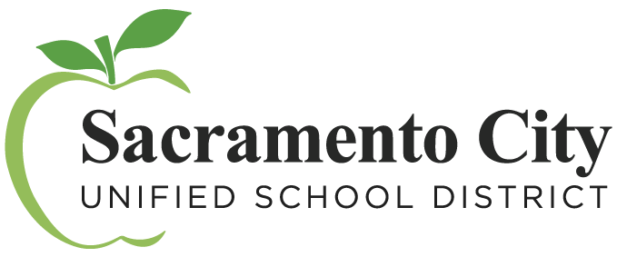
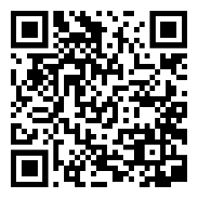
Questions about Primary.Health? Contact 650-275-5419
January 2022

SCAN the QR code to WATCH
a video on how to test.

